Task 1
Read the texts below. Match choices A-H to 1-5. There are three choices you do not need to use.

1
2
3

4
5

Which advertisement is for people who ___________?
A want to buy bicycles
B prefer an active pastime
C want to borrow a lot of money
D want brand name accessories
E need to repair a car
F want to host a party
G want to see a show
H need to go somewhere

Task 2
Read the text below. For questions 6-10 choose the correct answer A, B, C or D.
How to Make an Impressive Speech
Having a tough time deciding on what persuasive speech topics to talk about? Don’t sweat it. First, you must know your target audience very well. Know their age, sex, educational attainments and career experiences. Find out what their beliefs, dreams and goals are. What keeps them excited or awake at night? If possible, know their personal, cultural, social, religious and political backgrounds. This will prevent you from saying something that might be offensive to a particular race or culture.
Then, based on the information gathered from your audience, make a list of persuasive speech ideas that might fit their personality, status or background. Remember that the worst thing you could do is deliver a boring speech, so try to come up with controversial yet useful themes. Make persuasive speech topics that will benefit your audience. Remember people are always thinking of “WIIFM” (What’s In It For Me?). If they do not see any good results or advantages for listening to your speech, they will not be interested or responsive.
Choosing your topics, check those items that you are either are an authority on or are very familiar with. Your audience will look up to people with authority. If they perceive you as someone who is an expert on a subject, they would be more likely to listen to you and accept your viewpoints.
Do proper research over the Internet and libraries to come up with your persuasive speech ideas. During your research, take a note of the most interesting or helpful facts relevant to your audience. Keep an open mind and relate how your research can solve their problems or improve any aspect of their life.
Some people are naturally skeptical, so make your statements well-grounded: gather statistics, facts, presentations, case studies or true stories. Make sure you note the source or reference.
Finding persuasive speech topics is easy if you follow the guidelines above.

6 According to the text, which is the first thing you should do to impress the audience?
A Wake them up with a shocking statement.
B Share your views and opinions with them.
C Know the people who you speak to.
D Find out if you are of similar background.
7 According to the text, what do people expect most from your speech?
A It should be full of ideas.
B It should be instructive.
C It should be useful.
D It should be funny.
8 Which topics should be preferred?
A Topics well-known to the audience.
B Topics you have got good knowledge of.
C Topics conforming with the audience’s opinion.
D Topics connected with widely accepted ideas.
9 Which of the following is the phrase “keep an open mind” (paragraph 4) closest in meaning to?
A Be ready to accept views and opinions of others.
B Help the audience express their view and ideas.
C Know the subject you are talking about.
D Put a lot of thought in your work.
10 According to the text, which of the following is NOT mentioned in the text?
A Prove what you are going to say.
B Conduct preliminary research.
C Make references to your sources.
D Put your speech online.

Task 3
Read the texts below. Match choices A-H to 11-16. There are two choices you do not need to use.

11
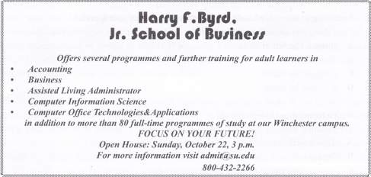
12
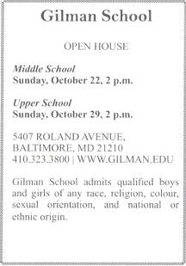
13
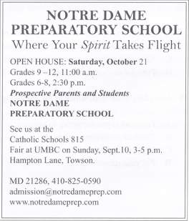
14
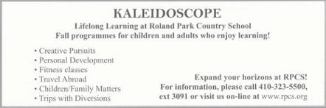
15
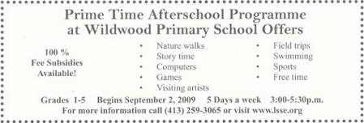
16
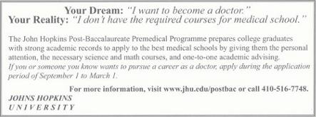

Which of the following schools ______________________?
A accepts applications starting October 1
B adheres to a policy of non-discrimination
C offers courses for college graduates only
D offers activities for young learners
E runs different programmes for all ages
F offers professional development courses
G invites students of Grades 6-12
H combines classroom education and hands-on training

Task 4
Read the text below. Choose from A-H the one which best fits each space 17-22.
There are two choices you do not need to use.
The Boy Scout Who Was Tintin
As with many great fictional heroes, there are several possible models who may or may not have inspired the character of the brave boy reporter Tintin. But one of the most likely was a Danish youngster named Palle Huld, (17) __________ to travel around the world in imitation of Jules Verne’s Phileas Fogg. In his case, he was given just 46 days to accomplish the feat, wasn’t allowed a companion and was forbidden to travel by aeroplane. Nevertheless, Huld managed it in 44 days. Not was it only his age and dauntless spirit (18) ____________. It was also his appearance. He had freckles, a snub nose and unruly bright-red hair.
Huld, (19) ____________, was chosen from applicants, and set off among a storm of publicity in March. His voyage was not without mishaps, yet he made it home – much to the relief of his poor mother, (20) _____________ during her boy’s absence to help her cope with the stress.
The following year, the enterprising Huld wrote his own account of his adventures, A Boy Scout Around the World, (21) ___________. His travels around the globe apparently gave him a taste for fame, too. He went on to become a distinguished actor,. (22) ________, including Tree Men In Search of a Troll.

A which was translated into several languages
B who at the age of 15 won a competition
C who had been prescribed sleeping pills
D that influenced his decision
E who was then working in an automobile dealership
F appearing in some 40 films
G that made him a truthful model for Tintin
H making his wishes come true

Task 5
Read the text below. For questions 23-32 choose the correct answer A, B, C or D.
The Meaning of Monkey Talk
Krak! Hok! Boom! These magic sounds 23) __________ random noises to us, but to a species of monkeys living in Ivory Coast, they (24) ________ a very specific meaning. During (25) ________ studies of the Campbell’s monkeys in the Tai National Park, naturalists (26) ___________ that when the monkeys spotted a leopard on the prowl, they would cry “Krak!” to (27) __________ other members of their group of the danger. A hok, by (28) _______________, alerted other monkeys that a crowned eagle was circling overhead. Boom seemed only to indicate that a branch had broken (29) ___________ a nearby tree. What particularly intrigued the researchers, however, was the fact that the creatures weren’t just (30) ____________ certain sounds to certain events, but seemed to have developed a kind of syntax. Sometimes, for a(an) (31) ________ but more general threat: so krak-oo would mean that there was danger, but not (32) _____ from a leopard. “The language of the Campbell’s monkeys may be “the most complex example of ‘proto-syntax’ in animal communication known to date”, the researches told.
23 A though B like C even D how
24 A pass B transport C bring D carry
25 A intensive B hard C busy D strong
26 A looked B observed C examined D watched
27 A say B show C warn D save
28 A contrast B chance C accident D mistake
29 A of B away C off D out
30 A combining B joining C uniting D linking
31 A same B equal C alike D similar
32 A surely B completely C necessarily D certainly

Task 6
Read the texts below. For questions 33-42 choose the correct answer A, B, C or D.
The Leaning Tower of Pisa Has Never Been Straight
Soon after building started in 1173, the foundation of the Pisa tower settled unevenly. Construction (33)_________, and was continued only a 100 year later. It then became visibly clear that the Tower is leaning, tilting to the south.
Since regular measuring of the tower began in 1911, the top of the tower (34)__________ 1.2 millimetres per year. In 1989, the Tower of Pisa Project Consortium commissioned engineers (35) ________ the Leaning Tower. Because the Tower tilted in different directions in its first years, it is slightly curved, like a banana. Engineers are working on the footing of the Tower rather than the structure, (36) ____________ to ease the top back about 20 cm. but it means that (37) _______ tower will remain leaning.
33 A are stopped B has stopped C is stopped D stopped
34 A has moved B was moved C was moving D had moved
35 A stabilized B stabilize C stabilizes D to stabilize
36 A hopes B hope C hoping D hoped
37 A the 800-years’ old B the 800-year old C the 800-year’s old D the 800-years old

The Swiftly Evolving Blackcap
Evolution doesn’t have to take centuries. In the case of the Blackcap songbird, (38) _______ decades were enough. The birds breed in the forests of Southern Germany, and traditionally fly to Spain for the winter. Most still make the journey south, but since the 1960s, 10% (39) _____ to wintering in England, where the colder climate is more than (40) _________ by the food left out on bird tables – a postwar phenomenon. These birds have rounder wings than their Spanish cousins (which provide better mobility but are (41) _________ suited to long-distance flight) and longer, narrower beaks, better suited to bread and nuts than to olives. Researchers speculate that if the birds (42) ____ to evolve in this way, they could eventually become a distinct species.
38 A a little B few C little D a few
39 A have taken B taken C has taken D taking
40 A balance B balanced C balances D balancing
41 A little B least C less D the least
42 A will continue B continues C continued D continue

43 Writing
You would like to work in Great Britain this summer. And you have read this advertisement in a newspaper

London Language Summer School
is looking for young energetic helpers.
Duties include helping with different outdoor activities.
Helpers must be good organizers, keen on sports and be able to work at any time, including evenings, from 1st-30th August.
Intermediate level of English is essential.
Please apply in writing to Tom Griffin.
The deadline for application is June 15th.

Write a letter of application. In your letter write about:
- why you are writing
- your personal qualities, language skills and experience with children
- why you think this work experience would be important for your future
Write a letter of at least 100 words. Do not write your own name, any dates, addresses or other personal information. Start your letter in an appropriate way.

